Prompt Engineering Assignment # 4
Question 1: Zero-Shot Prompting
Prompt:
Read this movie review and tell me if the person liked the movie or not. Review: "The acting was okay, but the story was very boring and the ending made no sense. I wouldn't watch it again
AI Response:
The reviewer did not like the movie. While they gave a mild compliment to the acting, they found the story boring, the ending confusing, and wouldn't watch it again — overall a negative review.

Question 2: One-Shot Prompting
Prompt:
I want you to change food names into their colors. Example: Apple=Red New Item: Grapes=?
AI Response:
Grapes = Purple

Question 3: Few-Shot Prompting
Prompt:
Write a very short, two-word exciting product description for these items:
1. Sports Car: Fast Speed
2. Energy Drink: Pure Power
3. Gaming Laptop: Ultimate Play
4. Running Shoes:
AI Response:
- Running Shoes: Unstoppable Stride

Question 4: System Prompting
Prompt:
You are a helpful assistant for a small tech shop.
1. Always start by saying "Hello! How can I help you today?"
2. Do not give medical advice or legal advice.
3. Use a friendly and polite tone.
4. If you don't know the answer, tell the customer to wait for a human staff member.
AI Response:
Hello! How can I help you today? 😊
I'm here to assist you with any questions about our tech products and services. Whether you're looking for help with a device, want to know about our latest offerings, or need some tech advice, feel free to ask!

Question 5: Role Prompting
Prompt:
Act like an expert Computer Network Engineer. I am setting up a small office. Can you explain why I should use a Subnet Mask and how it helps manage my IP addresses?
AI Response:
Hello! How can I help you today? 😊
Great question! Here's a simple breakdown of subnet masks and why they matter for your small office network:
What is a Subnet Mask? A subnet mask divides your IP addresses into two parts — the network portion and the device (host) portion. A common example for a small office is 255.255.255.0.
Why You Should Use One:
1. Organizes Your Network It defines which devices belong to the same local network. For example, all devices with IPs in the range 192.168.1.1 – 192.168.1.254 are on the same subnet and can communicate directly.
2. Efficient IP Address Management It controls how many devices your network can support. A /24 subnet (255.255.255.0) gives you 254 usable IP addresses — plenty for a small office.
3. Reduces Unnecessary Traffic Devices only broadcast to others within their subnet, keeping traffic contained and your network running smoothly.
4. Improves Security You can separate departments (e.g. Finance vs. General Staff) into different subnets, limiting who can access what.
5. Enables Routing Between Networks If you ever expand, subnet masks help your router intelligently direct traffic between different network segments.
For a small office, a simple 255.255.255.0 subnet mask is typically all you need to get started cleanly and efficiently.
Would you like help choosing the right IP range or setting up your router? 😊

Question 6: Contextual Prompting
Prompt:
I am opening a new library. We have 500 books, 10 tables, and 2 computer desks. We only have 50,000 left for furniture. We need to focus on a "Quiet Zone" for students and a "Kids Corner" with colorful rugs. Based only on these details, please write a simple floor plan and a budget plan for the remaining 50,000.
AI Response:
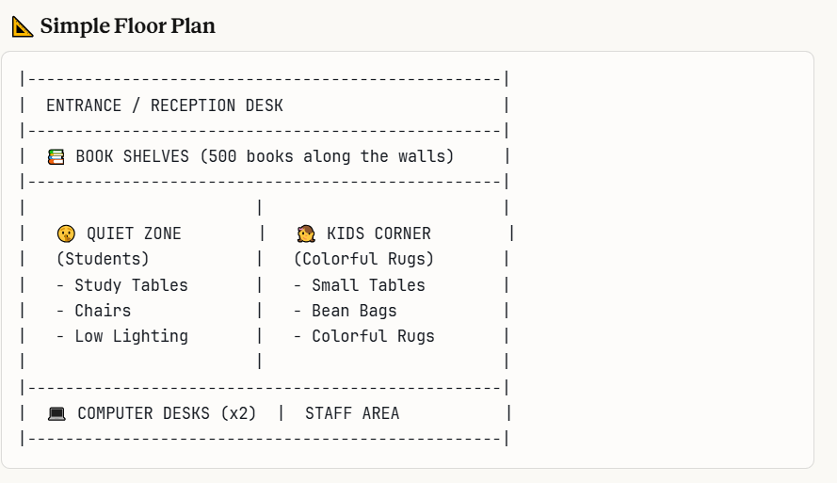

💰 Budget Plan — PKR 50,000
Item | Details | Estimated Cost
Study Tables (Quiet Zone) | 10 tables | PKR 8,000
Chairs (Quiet Zone) | 40 chairs | PKR 6,000
Kids Corner Small Tables | 4 small tables | PKR 3,000
Kids Chairs (small) | 20 small chairs | PKR 2,500
Colorful Rugs (Kids Corner) | 3–4 large rugs | PKR 4,000
Bean Bags (Kids Corner) | 10 bean bags | PKR 3,500
Book Shelves | 20 shelves | PKR 8,000
Reception Desk | 1 desk + chair | PKR 4,000
Computer Desk Setup | 2 desks + chairs | PKR 3,500
Lighting | Quiet zone + general | PKR 4,000
Signage & Decor | Zone labels, wall art | PKR 2,000
Miscellaneous / Contingency | Unexpected costs | PKR 1,500
TOTAL |  | PKR 50,000

⚠️ Note: PKR 50,000 is a very tight budget for a full library in Pakistan. It is strongly recommended to shop smart — consider local furniture markets like Rang Mahal or Shershah in Karachi, or Hall Road in Lahore for affordable options.
Suggested Priority Order:
- 📚 Book Shelves
- 🪑 Tables & Chairs (Quiet Zone)
- 💻 Computer Desk Setup
- 👧 Kids Corner (rugs, bean bags)
- 💡 Lighting & Decor
Would you like help planning the shopping or finding budget-friendly furniture suppliers in Pakistan? 😊

